

oneM2M
Technical Report
Document Number | TR-0031-V0.5.0
Document Name: | LWM2M DM & Interworking Enhancements
Date: | 2018-Jan-09
Abstract: | This document is a study to enhance existing LWM2M Device Management capabilities in the CSE to support a complete mapping of LWM2M objects to oneM2M <mgmtObj> resources and to provide an alternative approach to LWM2M Interworking using <mgmtObj> resources.
Template Version: January 2017 (Do not modify)

The present document is provided for future development work within oneM2M only. The Partners accept no liability for any use of this report.
The present document has not been subject to any approval process by the oneM2M Partners Type 1. Published oneM2M specifications and reports for implementation should be obtained via the oneM2M Partners' Publications Offices.

About oneM2M
The purpose and goal of oneM2M is to develop technical specifications which address the need for a common M2M Service Layer that can be readily embedded within various hardware and software, and relied upon to connect the myriad of devices in the field with M2M application servers worldwide.
More information about oneM2M may be found at: http//www.oneM2M.org
Copyright Notification
© 2017, oneM2M Partners Type 1 (ARIB, ATIS, CCSA, ETSI, TIA, TSDSI, TTA, TTC).
All rights reserved.
The copyright and the foregoing restriction extend to reproduction in all media.

Notice of Disclaimer & Limitation of Liability
The information provided in this document is directed solely to professionals who have the appropriate degree of experience to understand and interpret its contents in accordance with generally accepted engineering or other professional standards and applicable regulations. No recommendation as to products or vendors is made or should be implied.
NO REPRESENTATION OR WARRANTY IS MADE THAT THE INFORMATION IS TECHNICALLY ACCURATE OR SUFFICIENT OR CONFORMS TO ANY STATUTE, GOVERNMENTAL RULE OR REGULATION, AND FURTHER, NO REPRESENTATION OR WARRANTY IS MADE OF MERCHANTABILITY OR FITNESS FOR ANY PARTICULAR PURPOSE OR AGAINST INFRINGEMENT OF INTELLECTUAL PROPERTY RIGHTS. NO oneM2M PARTNER TYPE 1 SHALL BE LIABLE, BEYOND THE AMOUNT OF ANY SUM RECEIVED IN PAYMENT BY THAT PARTNER FOR THIS DOCUMENT, WITH RESPECT TO ANY CLAIM, AND IN NO EVENT SHALL oneM2M BE LIABLE FOR LOST PROFITS OR OTHER INCIDENTAL OR CONSEQUENTIAL DAMAGES. oneM2M EXPRESSLY ADVISES ANY AND ALL USE OF OR RELIANCE UPON THIS INFORMATION PROVIDED IN THIS DOCUMENT IS AT THE RISK OF THE USER.

Contents
Contents 3
1 Scope 4
2 References 4
2.1 Normative references 4
2.2 Informative references 4
3 Definitions, symbols and abbreviations 4
3.1 Definitions 4
4 Conventions, 5
5 Analysis of LWM2M Objects and Motivation for Mapping to <mgmtObj> Resources 5
6 Generic Procedure for Mapping LWM2M Objects to <mgmtObj> Resources 15
7 LWM2M Interworking Procedures Using Mapping of LWM2M Objects to <mgmtObj> Resources 20
8 Conclusion 23
Annex A: 24
Annex B: 30
Annex C: 33
History 36

1 Scope
The present document is a study for enhancing existing LWM2M Device Management capabilities within the CSE as well as provide an alternative approach to LWM2M Interworking. An approach will be defined to address the issue of how to generically map LWM2M Objects to oneM2M <mgmtObj> resources in a dynamic way.

2 References
References are either specific (identified by date of publication and/or edition number or version number) or non-specific. For specific references,only the cited version applies. For non-specific references, the latest version of the referenced document (including any amendments) applies.

2.1 Normative references
Not applicable.

2.2 Informative references
The following referenced documents are not necessary for the application of the present document but they assist the user with regard to a particular subject area.
[i.1] oneM2M Drafting Rules (http://member.onem2m.org/Static_pages/Others/Rules_Pages/oneM2M-Drafting-Rules-V1_0.doc)
[i.2] oneM2M TS-0002: "Requirements".
[i.3] oneM2M TS-0001: "Functional Architecture".
[i.4] oneM2M TS-0005: "Management Enablement (OMA)".
[i.5] oneM2M TS-0014: "LWM2M Interworking".
[i.6] OMA-RD-LightweightM2M-V1_0”OMA Lightweight Machine to Machine Requirement”
[i.7] OMA-AD-LightweightM2M-V1_0 “OMA Lightweight Machine to Machine Architecture”
[i.8] OMA-TS-LightweightM2M-V1_0-20170208-D “Lightweight Machine to Machine Technical Specification”
[i.9] OMA LWM2M Object Registry
(http://technical.openmobilealliance.org/Technical/technical-information/omna/lightweight-m2m-lwm2m-object-registry)
[i.10] OMA-TS-LWM2M_ConnMgmt-V1_1-20170201 “Lightweight M2M – Connectivity Management Object (LwM2M Object – ConnMgmt)
[i.11] OMA-SUP-XML_LWM2M_Cellular_connectivity-V1_0-20170301-D.xml

3 Definitions, symbols and abbreviations

3.1 Definitions
For the purposes of the present document, the [following] terms and definitions apply:
One-to-one mapping: the process in which a LWM2M object is mapped to a corresponding oneM2M <mgmtObj> resource

4 Conventions,
The key words “Shall”, ”Shall not”, “May”, ”Need not”, “Should”, ”Should not” in this document are to be interpreted as described in the oneM2M Drafting Rules [i.1]

5 Analysis of LWM2M Objects and Motivation for Mapping to <mgmtObj> Resources
The oneM2M <mgmtObj> resource is defined to support device management capabilities within the CSE. The design of the <mgmtObj> resource allows mapping to the underlying DM technology specific resources such as LWM2M. In essence, the <mgmtObj> resource is a template resource in which <mgmtObj> specializations are created from, based on the DM functionality it represents. For example, the [memory] resource is a specialized <mgmtObj> resource in which a device’s available and total memory are exposed as <mgmtObj> resource attributes for management purposes.
By as such, there should be a one to one relationship between the specialized oneM2M resource with that of the underlying DM resource.
TS-0005 provides mappings between specialized oneM2M <mgmtObj> resources and a subset of the LWM2M defined Objects. Table 5-1 shows a listing of the specialized oneM2M <mgmtObj> resources currently defined in that are mapped to the corresponding LWM2M Objects. In addition, the objectID attribute of each specialized <mgmtObj> resource is provided to show the mapping relationship. It can be seen that there are 19 specialized <mgmtObj> resources defined but not all of them are mapped to LWM2M Objects. Furthermore, there are four <mgmtObj> resource specializations ([memory], [battery], [deviceInfo], and [reboot]) that are mapped to a single LWM2M Device object.
Table 5-1 – oneM2M <mgmtObj> Specialization Resources for LWM2M
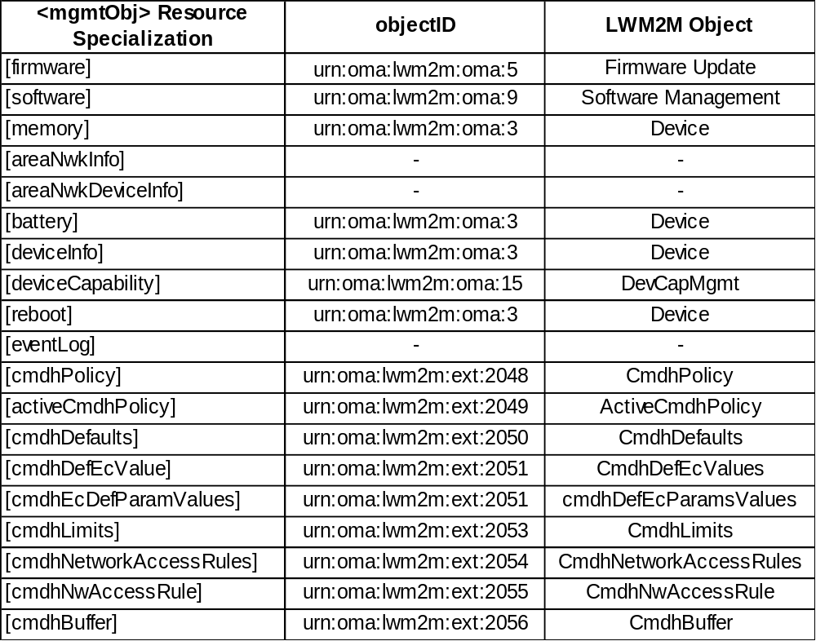
shows the OMA LWM2M Object Registry found in . As can be seen, the total number of LWM2M Objects in the registry is 86 objects, which is much more than the number of specialized oneM2M <mgmtObj> resources. As a result, not all LWM2M Objects are mapped to oneM2M <mgmtObj> resource specializations.
Table 5-2 - OMA LWM2M Object Registry
Object ID | URN | Object Name | Object DDF File | Object Technical Specification | Owner
0 | urn:oma:lwm2m:oma:0 | LWM2M Security | LWM2M_Security-v1_0.xml | OMA-TS-LightweightM2M V1.0 | OMA
1 | urn:oma:lwm2m:oma:1 | LWM2M Server | LWM2M_Server-v1_0.xml | OMA-TS-LightweightM2M V1.0 | OMA
2 | urn:oma:lwm2m:oma:2 | Access Control | LWM2M_Access_Control-v1_0.xml | OMA-TS-LightweightM2M V1.0 | OMA
3 | urn:oma:lwm2m:oma:3 | Device | LWM2M_Device-v1_0.xml | OMA-TS-LightweightM2M V1.0 | OMA
4 | urn:oma:lwm2m:oma:4 | Connectivity Monitoring | LWM2M_Connectivity_Monitoring-v1_0.xml | OMA-TS-LightweightM2M V1.0 | OMA
5 | urn:oma:lwm2m:oma:5 | Firmware | LWM2M_Firmware_Update-v1_0.xml | OMA-TS-LightweightM2M V1.0 | OMA
6 | urn:oma:lwm2m:oma:6 | Location | LWM2M_Location-v1_0.xml | OMA-TS-LightweightM2M V1.0 | OMA
7 | urn:oma:lwm2m:oma:7 | Connectivity Statistics | LWM2M_Connectivity_Statistics-v1_0.xml | OMA-TS-LightweightM2M V1.0 | OMA
8 | urn:oma:lwm2m:oma:8 | Lock and Wipe | x | OMA-TS-LWM2M LockWipe V1.0 | OMA
9 | urn:oma:lwm2m:oma:9 | Sofware Management | x | OMA-TS-SWMGMT V1.0 | OMA
10 | urn:oma:lwm2m:oma:10 | Cellular connectivity | x | OMA-TS-LWM2M_ConnMgmt-V1_0 | OMA
11 | urn:oma:lwm2m:oma:11 | APN connection profile | x | OMA-TS-LWM2M_ConnMgmt-V1_0 | OMA
12 | urn:oma:lwm2m:oma:12 | WLAN connectivity | x | OMA-TS-LWM2M_ConnMgmt-V1_0 | OMA
13 | urn:oma:lwm2m:oma:13 | Bearer selection | x | OMA-TS-LWM2M_ConnMgmt-V1_0 | OMA
14 | urn:oma:lwm2m:oma:14 | Software Component | x | OMA-TS-LWM2M_SwMgmt-V1_0 | OMA
15 | urn:oma:lwm2m:oma:15 | DevCapMgmt | x | OMA-TS-LWM2M_ DevCapMgmt- V1_0 | OMA
16 | urn:oma:lwm2m:oma:16 | Porfolio | LWM2M_Portfolio-v1_0.xml | OMA-TS-LWM2M_PortfolioObj-V1_0 | OMA
2048 | urn:oma:lwm2m: ext:2048 | CmdhPolicy | X | Management Enablement (OMA) | OneM2M
2049 | urn:oma:lwm2m: ext:2049 | ActiveCmdhPolicy | X | Management Enablement (OMA) | OneM2M
2050 | urn:oma:lwm2m: ext:2050 | CmdhDefaults | X | Management Enablement (OMA) | OneM2M
2051 | urn:oma:lwm2m: ext:2051 | CmdhDefEcValues | X | Management Enablement (OMA) | OneM2M
2052 | urn:oma:lwm2m: ext:2052 | cmdhDefEcParamsValues | X | Management Enablement (OMA) | OneM2M
2053 | urn:oma:lwm2m: ext:2053 | CmdhLimits | X | Management Enablement (OMA) | OneM2M
2054 | urn:oma:lwm2m: ext:2054 | CmdhNetworkAccessRules | X | Management Enablement (OMA) | OneM2M
2055 | urn:oma:lwm2m: ext:2055 | CmdhNwAccessRule | X | Management Enablement (OMA) | OneM2M
2056 | urn:oma:lwm2m: ext:2056 | CmdhBuffer | X | Management Enablement (OMA) | OneM2M
3200 | urn:oma:lwm2m: ext:3200 | Digital | 3200.xml | SmartOject Guideline | IPSO Alliance
3201 | urn:oma:lwm2m: ext:3201 | Digital Output | 3201.xml | SmartOject Guideline | IPSO Alliance
3202 | urn:oma:lwm2m: ext:3202 | Analogue Input | 3202.xml | SmartOject Guideline | IPSO Alliance
3203 | urn:oma:lwm2m: ext:3203 | Analogue Output | 3203.xml | SmartOject Guideline | IPSO Alliance
3300 | urn:oma:lwm2m: ext:3300 | Generic Sensor | 3300.xml | SmartOject Guideline | IPSO Alliance
3301 | urn:oma:lwm2m: ext:3301 | Illuminance Sensor | 3301.xml | SmartOject Guideline | IPSO Alliance
3302 | urn:oma:lwm2m: ext:3302 | Presence Sensor | 3302.xml | SmartOject Guideline | IPSO Alliance
3303 | urn:oma:lwm2m: ext:3303 | Temperature Sensor | 3303.xml | SmartOject Guideline | IPSO Alliance
3304 | urn:oma:lwm2m: ext:3304 | Humidity Sensor | 3304.xml | SmartOject Guideline | IPSO Alliance
3305 | urn:oma:lwm2m: ext:3305 | Power Measurement | 3305.xml | SmartOject Guideline | IPSO Alliance
3306 | urn:oma:lwm2m: ext:3306 | Actuation | 3306.xml | SmartOject Guideline | IPSO Alliance
3308 | urn:oma:lwm2m: ext:3308 | Set Point | 3308.xml | SmartOject Guideline | IPSO Alliance
3310 | urn:oma:lwm2m: ext:3310 | Load Control | 3310.xml | SmartOject Guideline | IPSO Alliance
3311 | urn:oma:lwm2m: ext:3311 | Light Control | 3311.xml | SmartOject Guideline | IPSO Alliance
3312 | urn:oma:lwm2m: ext:3312 | Power Control | 3312.xml | SmartOject Guideline | IPSO Alliance
3313 | urn:oma:lwm2m: ext:3313 | Accelerometer | 3313.xml | SmartOject Guideline | IPSO Alliance
3314 | urn:oma:lwm2m: ext:3314 | Magnetometer | 3314.xml | SmartOject Guideline | IPSO Alliance
3315 | urn:oma:lwm2m: ext:3315 | Barometer | 3315.xml | SmartOject Guideline | IPSO Alliance
3316 | urn:oma:lwm2m: ext:3316 | Voltage | 3316.xml |  | IPSO Alliance
3317 | urn:oma:lwm2m: ext:3317 | Current | 3317.xml |  | IPSO Alliance
3318 | urn:oma:lwm2m: ext:3318 | Frequency | 3318.xml |  | IPSO Alliance
3319 | urn:oma:lwm2m: ext:3319 | Depth | 3319.xml |  | IPSO Alliance
3320 | urn:oma:lwm2m: ext:3320 | Percentage | 3320.xml |  | IPSO Alliance
3321 | urn:oma:lwm2m: ext:3321 | Altitude | 3321.xml |  | IPSO Alliance
3322 | urn:oma:lwm2m: ext:3322 | Load | 3322.xml |  | IPSO Alliance
3323 | urn:oma:lwm2m: ext:3323 | Pressure | 3323.xml |  | IPSO Alliance
3324 | urn:oma:lwm2m: ext:3324 | Loudness | 3324.xml |  | IPSO Alliance
3325 | urn:oma:lwm2m: ext:3325 | Concentration | 3325.xml |  | IPSO Alliance
3326 | urn:oma:lwm2m: ext:3326 | Acidity | 3326.xml |  | IPSO Alliance
3327 | urn:oma:lwm2m: ext:3327 | Conductivity | 3327.xml |  | IPSO Alliance
3328 | urn:oma:lwm2m: ext:3328 | Power | 3328.xml |  | IPSO Alliance
3329 | urn:oma:lwm2m: ext:3329 | Power Factor | 3329.xml |  | IPSO Alliance
3330 | urn:oma:lwm2m: ext:3330 | Distance | 3330.xml |  | IPSO Alliance
3331 | urn:oma:lwm2m: ext:3331 | Energy | 3331.xml |  | IPSO Alliance
3332 | urn:oma:lwm2m: ext:3332 | Direction | 3332.xml |  | IPSO Alliance
3333 | urn:oma:lwm2m: ext:3333 | Time | 3333.xml |  | IPSO Alliance
3334 | urn:oma:lwm2m: ext:3334 | Gyrometer | 3334.xml |  | IPSO Alliance
3335 | urn:oma:lwm2m: ext:3335 | Color | 3335.xml |  | IPSO Alliance
3336 | urn:oma:lwm2m: ext:3336 | GPS Location | 3336.xml |  | IPSO Alliance
3337 | urn:oma:lwm2m: ext:3337 | Positioner | 3337.xml |  | IPSO Alliance
3338 | urn:oma:lwm2m: ext:3338 | Buzzer | 3338.xml |  | IPSO Alliance
3339 | urn:oma:lwm2m: ext:3339 | Audio Clip | 3339.xml |  | IPSO Alliance
3340 | urn:oma:lwm2m: ext:3340 | Timer | 3340.xml |  | IPSO Alliance
3341 | urn:oma:lwm2m: ext:3341 | Addressable Text Display | 3341.xml |  | IPSO Alliance
3342 | urn:oma:lwm2m: ext:3342 | On/Off Switch | 3342.xml |  | IPSO Alliance
3343 | urn:oma:lwm2m: ext:3343 | Lever Control | 3343.xml |  | IPSO Alliance
3344 | urn:oma:lwm2m: ext:3344 | Up/Down Control | 3344.xml |  | IPSO Alliance
3345 | urn:oma:lwm2m: ext:3345 | Multiple Axis Joystick | 3345.xml |  | IPSO Alliance
3346 | urn:oma:lwm2m: ext:3346 | Rate | 3346.xml |  | IPSO Alliance
3347 | urn:oma:lwm2m: ext:3347 | Push Button | 3347.xml |  | IPSO Alliance
3348 | urn:oma:lwm2m: ext:3348 | Multistate Selector | 3348.xml |  | IPSO Alliance
10241 | urn:oma:lwm2m:x:10241 | HostDeviceInfo | x | x | AT&T
10242 | urn:oma:lwm2m:x:10242 | 3-PhasePM | 3-PhasePM.xml | x | Odins
10243 | urn:oma:lwm2m:x:10243 | singlePhasePM | singlePhasePM.xml | x | Odins
10244 | urn:oma:lwm2m:x:10244 | VehicleControlUnit | VehicleControlUnit.xml | x | Works System
10245 | urn:oma:lwm2m:x:10245 | Relay Management | x | x | Vodafone Group Services Ltd
10246 | urn:oma:lwm2m:x:10246 | CrowdBox Measurements | x | x | Vodafone Group Services Ltd
10247 | urn:oma:lwm2m:x:10247 | Neighbour Cell Report | x | x | Vodafone Group Services Ltd
10248 | urn:oma:lwm2m:x:10248 | Connected UE Measurements | x | x | Vodafone Group Services Ltd
10249 | urn:oma:lwm2m:x:10249 | Connected UE Report | x | x | Vodafone Group Services Ltd

In comparing Table 5-1 and , there are many more LWM2M Objects defined than there are oneM2M <mgmtObj> specializations. In order for oneM2M to provide complete support for all LWM2M Objects, many new <mgmtObj> resources need to be defined. Currently, <mgmtObj> specializations are defined during the standardization process and captured in TS-0005. However, this process is very tedious, time consuming, and not sustainable. There needs to be a way in which <mgmtObj> specializations can be dynamically defined for new LWM2M Objects outside of the oneM2M standardization. In addition and to make life simpler for application developers, a 1:1 mapping between LWM2M objects and oneM2M <mgmtObj> specializations is also needed.
First, let us discuss what are the benefits of using <mgmtObj> specializations for LWM2M device management as well as LWM2M Interworking. oneM2M <mgmtObj> specializations are defined to be child resources of the <node> resource and are used for management purposes. The <node> resource is associated with a device and provides resources for managing the device. There can be multiple <AE> resources associated with the device but only one <node> resource can be associated with a device. Hence the use of a <node> resource and <mgmtObj> specialization child resources is well-suited for management of a device.
The <mgmtObj> resource contains two attributes “objectIDs” and “objectPath” that shows the mapping of a <mgmtObj> specialization to a corresponding LWM2M Object. Table 5-3 shows the context of these two attributes for the [memory] specialization and the corresponding LWM2M Object it is mapped to is shown in Table 5-4. The objectIDs attribute contains the URN of the LWM2M Object that the [memory] resource is mapped to and the objectPath contains the LWM2M Object instance for this particular [memory] resource.
Table 5-3 – oneM2M Context of [memory] Resource
Context | Mapping
objectId | urn:oma:lwm2m:oma:3
objectPath | /3/0 (instance 0 of Object 3)
Table 5-4 – LWM2M Device Object Definition
Name | Object ID | Instances | Mandatory | Object URN
Device | 3 | Single | Mandatory | urn:oma:lwm2m:oma:3

The <mgmtObj> resource also has an [objectAttribute] attribute that allows for mapping to a leaf node of a technology specific data model object such as LWM2M. This attribute provides the capability to map, one-for-one, a oneM2M attribute to a LWM2M resource. Using the example of the [memory] specialization, Table 5-5Table 5-5 shows the oneM2M attributes “memAvailable” and “memTotal” mapped to the LWM2M Device Object’s resources “10” and “21” as shown in Table 5-6Table 5-6. [Note that oneM2M <mgmtObj> resource specializations and attributes are mapped respectively to LWM2M objects and resources.]
Table 5-5 – Mapped [memory] Resource Attributes
Attribute Name of [memory] | Mapping to resources in LWM2M Device Object Instance
memAvailable | 10 estimated current available amount of memory in KB
memTotal | 21 total amount of storage space in KB in the LWM2M Device
Table 5-6 – LWM2M Device Object Resource Definitions
ID | Name | Operations | Instances | Mandatory | Type | Range or Enumeration | Units | Description
0 | Manufacturer | R | Single | Optional | String |  |  | Human readable manufacturer name
1 | Model Number | R | Single | Optional | String |  |  | A model identifier (manufacturer specified string)
2 | Serial Number | R | Single | Optional | String |  |  | Serial Number
…
10 | Memory Free | R | Single | Optional | Integer |  | KB | Estimated current available amount of storage space which can store data and software in the LWM2M Device (expressed in kilobytes).
21 | Memory Total | R | Single | Optional | Integer |  | KB | Total amount of storage space which can store data and software in the LWM2M Device (expressed in kilobytes).

The use of <mgmtObj> specializations for LWM2M DM and LWM2M Interworking allows for full mappings of the LWM2M data models to oneM2M resources while offloading the requirement that AE’s that access the <mgmtObj> resources need to also understand the LWM2M protocol. The AE only needs to perform oneM2M requests targeting oneM2M resources and attributes. The CSE, with knowledge of the mapping information, will then be able to interface to a LWM2M Server or an IPE. In addition, the ability to specify full mappings also allow for more granular operations at the oneM2M attribute level where requesting a reboot of a device could be accomplished with oneM2M’s partial addressing mechanism. This granular control allows for more optimized operations and limits unnecessary notifications between the CSE and an IPE.

6 Generic Procedure for Mapping LWM2M Objects to <mgmtObj> Resources
The need to specify a generic procedure for providing a complete mapping of oneM2M resources and attributes to LWM2M objects and resources is obvious when comparing Table 5-1 and . There are just too many LWM2M Objects defined that currently do not have a corresponding <mgmtObj> specialization defined in oneM2M. Furthermore, given that LWM2M also supports the ability for vendors to define their own vendor specific LWM2M Objects, this further compounds the issue from a oneM2M standardization perspective. For these reasons, a more generic and extensible procedure is proposed here to provide the capability for the CSE to support new LWM2M object mappings to oneM2M <mgmtObj> specializations.
Since there exists LWM2M Objects that do not have explicit mappings to oneM2M <mgmtObj> resources defined in TS-0005 [i.4], oneM2M can define a set of guidelines for generically mapping LWM2M objects to new oneM2M <mgmtObj> resources. These guidelines provide interoperability and extensibility between the two standards and ensure seamless interworking of LWM2M client and servers with oneM2M CSEs and AEs.
Below are the guidelines for generically mapping LWM2M Objects to oneM2M <mgmtObj> resources.
- For a given LWM2M object that is to be mapped to oneM2M, there must exist a definition file where information about the LWM2M object is defined. An example of such a definition file is found in [i.11] and is shown in Annex A for convenience. Using a template oneM2M schema file as shown in Annex B, a corresponding oneM2M <mgmtObj> XSD file will be created that is compliant with existing oneM2M XSD conventions as defined in TS-0004.
- The new XSD will have a base of “m2m:mgmtResource” and inherit all oneM2M defined <mgmtObj> common attributes. In addition, the new mgmtObj resource will include the oneM2M common types and subscription schema files. The name of both the resource and the schema file will be the concatenation of the LWM2M Object name. For example, the LWM2M Cellular connectivity object (object ID 10) will be given the name cellularConnectivity in oneM2M.
- For each LWM2M resource supported by the LWM2M object to be mapped, the XSD will support a corresponding oneM2M [objectAttribute] element. The name of the LWM2M resource will be used for the name of the oneM2M [objectAttribute] but the convention of the name will follow oneM2M naming conventions, e.g. LWM2M resource name “SMSC address” will be “smscAddress”.
- The order of the [objectAttribute] attributes will match the order of the LWM2M resources as specified by the LWM2M object’s resource definition file. This order matching is very important as it provides correctly ordered mappings between LWM2M resources and oneM2M attributes. This allows for easier translation of oneM2M [objectAttribute] attributes to the corresponding LWM2M resources whenever a request is made to manage a LWM2M device. The ordering will also help ensure that <mgmtObj> XSD files generated by different developers and for the same LWM2M object are the same.
- For each [objectAttribute] attribute, the following guidelines will be followed.
  - The type definition will be based on the mapping of LWM2M data types to oneM2M data types as defined in TS-0005 [i.4].
  - The minOccurs and maxOccurs settings will be based on the multiplicity (i.e. Single vs. Multiple) and the optionality (i.e. Manadatory vs. Optional) of the corresponding LWM2M resource. A mandatory attribute will have a minOccurs=1, while a optional attribute will have a minOccurs=0. An attribute with single multiplicity will have a maxOccurs=1, while an attribute with multiplicity greater than one will have a maxOccurs set to the specified limit or to unbounded if no limit is specified.
- An example of a oneM2M schema file that is mapped from a LWM2M resource definition file is shown in Annex C. Note the order of the oneM2M resource specific attributes match that of the LWM2M definition file, e.g. activatedProfileNames is mapped to Activated Profile Names and both appear first in their respective files. As long as the order of the oneM2M attributes match the order of the LWM2M resources, a mapping can be performed provided that both the oneM2M schema file and the LWM2M resource definition are available. This order matching enables the support of cases where the LWM2M resource ID are out of sequence or even in cases where there is a gap in the sequence of the LWM2M resource ID. For example, Table 7-1 lists the resources of the LWM2M Firmware Update object where resource ID 4 is missing. If the oneM2M schema file follows the same order that is shown in Table 7-1, the one for one mapping is preserved.
- When creating the <mgmtObj> associated with a LWM2M Object defined by this procedure, the following guidelines will be followed as shown in Table 6-1.
  - mgmtDefinitions will be set to the value “Unspecified”.
  - mgmtSchema will be set to the URI of where the XSD file created in Step 1 is located
  - objectIDs will be set to the URN of the corresponding LwM2M Object.
  - objectPaths can be included and configured with the prefix of the local path where the LWM2M Object resides on the LWM2M device.
  - mgmtLink can be included if the <mgmtObj> resource links to another <mgmtObj> resource to form a hierarchy of <mgmtObj> resources. This is used with LWM2M Objlink data type.
  - The inclusion of at least one [objectAttribute]. Note the order of the [objectAttribute] must follow the same order as specified by the LWM2M Object’s resource definition file.
  - The description attribute can be included to provide more specific information about the functionality of the <mgmtObj>. An example is the string “LWM2M:<object_ID>” to identify the <mgmtObj> is associated with LWM2M and to what Object ID.
Table 6-1 – <mgmtObj> Resource Specific Attributes
<mgmtObj> Attributes | Create  M/O | Description of Value During <mgmtObj> Create
mgmtDefinitions | M | Contains the value corresponding to “Unspecified”
mgmtSchema | O | URI of an XSD file that provides the resource definitions for this <mgmtObj> resource
objectIDs | M | URN of the corresponding LwM2M object
objectPaths | O | Contains the prefix of the local path the LWM2M Object resides at on the LWM2M device. The path will include the LWM2M object instance associated with this <mgmtObj> resource, e.g. /9/2 – this <mgmtObj> maps to software object instance 2.
mgmtLink | O | Contains a link to other <mgmtObj> resources to support a hierarchy of <mgmtObj> resources
[objectAttribute] | M | List of LWM2M resources mapped to oneM2M attributes one for one and in the order specified by the LWM2M Object’s resource definitions file.
Description | O | A text description that contains information about the LWM2M Object

These generic guidelines allow for the specification of a new <mgmtObj> schema definitions that can be referenced by the mgmtSchema attribute. The new schema definition (e.g. XSD) of the <mgmtObj> specialization will correspond to a LwM2M Object definition. The mgmtSchema will be configured during the creation of the specialized <mgmtObj> resource. The option to specify a URI in the mgmtSchema attribute allows the CSE to support interworking with new LWM2M Objects (e.g., those that were not available at the time of initial deployment of the CSE). This is especially true in the case of vendor specific LWM2M Objects. The URI will point to a location where the schema definition of the new <mgmtObj> specialization can be found and retrieved by the CSE to use.
Table 6-2 shows the resource specific attributes for the <mgmtObj> resource type with the inclusion of the mgmtSchema attribute.
Table 6-2 – Attributes of <mgmtObj> Resources
Attributes of <mgmtObj> | Multiplicity | RW/  RO/  WO | Description | <mgmtObjAnnc> Attributes
…
mgmtDefinition | 1 | WO | Specifies the type of <mgmtObj> resource e.g. software, firmware, memory. The list of the value of the attribute can be seen in annex D. | MA
mgmtSchema | 0..1 | WO | Contains a URI to the <mgmtObj> schema definition which will be used by the Hosting CSE to validate the syntax of incoming primitives targeting this <mgmtObj> resource.  This URI can refer to a oneM2M specified <mgmtObj> definition as well as other <mgmtObj> definitions. | MA
objectIDs | 0..1 (L) | RW | Contains the list of URNs that uniquely identify the technology specific data model objects (e.g. XSD schema definitions) used for this <mgmtObj> resource as well as the managed function and version it represents. This attribute will be provided during the creation of the <mgmtObj> resource and will not be modifiable afterwards.  If the <mgmtObj> resource is mapped to multiple technology specific data model objects, this attribute will list all URIs or URNs for each mapped technology specific data model objects. This is mandatory for the <mgmtObj>, for which the data model is not specified by oneM2M but mapped from technology specific data model. | OA
objectPaths | 0..1 (L) | RW | Contains the list of local paths of the technology specific data model objects on the managed entity which is represented by the <mgmtObj> resource in the Hosting CSE.  This attribute will be provided during the creation of the <mgmtObj>, so that the Hosting CSE can correlate the created <mgmtObj> with the technology specific data model object on the managed entity for further management operations. It will not be modifiable after creation.  The format of this attribute will be a local technology specific data model object path in the form as specified by technology specific protocol. (e.g. "./anyPath/Fw1" in OMA DM [Error: Reference source not found], "Device.USBHosts.Host.3." in BBF TR-069 [Error: Reference source not found]).  The combination of the objectPaths and the objectIDs attribute, allows to address the technology specific data model. | OA
mgmtLink | 0..1 (L) | RW | This attribute contains reference to a list of other <mgmtObj> resources in case a hierarchy of <mgmtObj> is needed. | OA
[objectAttribute] | 0..n | RW | Each [objectAttribute] is mapped from a leaf node of a hierarchical structured technology specific data model object (including oneM2M data model and the technology specific data model objects) based on the mapping rules below the table. | OA
description | 0..1 | RW | Text format description of <mgmtObj>. | OA

Figure 6-1 shows the updated procedure a Hosting CSE executes to create a new, <mgmtObj> specialization resource using the mgmtSchema attribute. The URI of the schema file for the <mgmtObj> specialization resource is provided in the mgmtSchema attribute of the request to create the <mgmtObj> resource. The Hosting CSE then retrieves the schema file using the URI and processes the request as outlined below.
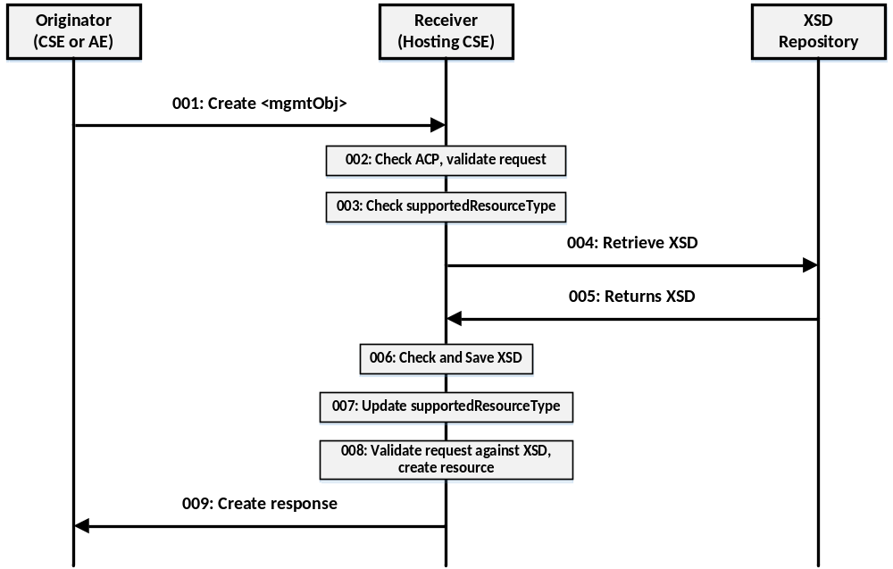Figure 6-1 – Procedure for CSE to Support New Specialized <mgmtObj> Resources

Step 001: The Originator will send mandatory parameters and can send optional paramters in the Request message for a CREATE operation of a <mgmtObj> specialization resource. The specialized <mgmtObj> resource contains a full mapping of the underlying LWM2M Object and includes the URI of the XSD for the new specialized resource in the mgmtSchema attribute.
Step 002: The Receiver will:
- Check if the Originator has the appropriate privileges for performing the request.
- Verify that the name for the created resource as suggested by the resourceName parameter does not already exist among child resources of the targeted resource.

Step 003: The Receiver will check if the type <mgmtObj> specialization is present in the supportedResourceType attribute of the CSEBase. If found in the supportedResourceType attribute, go to Step 8; otherwise, go to Step 4.
Step 004: The Receiver extracts the contents of the mgmtSchema attribute and retrieves an XSD from the XSD Repository.
Step 005: The XSD Repository returns the XSD for the specialized <mgmtObj> resource.
Step 006: The Receiver checks the received XSD is well formed and if it is, saves the XSD to the Receiver’s local XSD repository.
Step 007: The Receiver updates the supportedResourceType attribute with the type of the specialized <mgmtObj>.
Step 008: The Receiver completes processing the CREATE request.
- Assign a Resource-ID to the resource to be created.
- Assign values for mandatory RO mode attributes of the resource and override values provided for other mandatory attributes and where allowed by the resource type definition and if not provided by the Originator itself.
- The Receiver will assign a value to the following common attributes:
  - parentID;
  - creationTime;
  - expirationTime: if not provided by the Originator, the Receiver will assign the maximum value possible (within the restriction of the Receiver policies). If the value provided by the Originator cannot be supported, due to either policy or subscription restrictions, the Receiver will assign a new value;
  - lastModifiedTime: which is equals to the creationTime;
  - Any other RO (Read Only) attributes within the restriction of the Receiver policies.
- The Receiver will check whether a creator attribute is included in the Content parameter of the request. If included, the creator attribute will not have a value in the Content parameter of the request. On the other hand if the creator attribute is not included in the Content parameter of the request, then the Receiver will not include the creator attribute in the resource to be created.
- On successful validation of the Create Request, the Receiver will create the requested resource.
- The Receiver will check if the created child resource leads to changes in its parent resource's attribute(s), if so the parent resource's attribute(s) will be updated.

Step 009: The Receiver will respond with mandatory parameters and can send optional parameters in Response message for CREATE operation.
General Exceptions:
- The Originator does not have the privileges to create a resource on the Receiver. The Receiver responds with an error.
- The resource with the specified name (if provided) already exists at the Receiver. The Receiver responds with an error.
- The provided information in Content is not accepted by the Receiver (e.g. missing mandatory parameter). The Receiver responds with an error.

7 LWM2M Interworking Procedures Using Mapping of LWM2M Objects to <mgmtObj> Resources
Figure 7-1 shows an example end-to-end procedure demonstrating how the procedures shown in Figure 6-1 can be utilized as part of LWM2M Interworking. The LWM2M Server and the IPE are co-located, and together they perform oneM2M procedures on behalf of the LWM2M Device. A LWM2M Device will initially register to the LWM2M Server and provides a list of all the LWM2M objects it supports. The LWM2M Server/IPE will then perform a oneM2M registration on behalf of the device and requests to create an <AE> resource. Once the <AE> resource is created, the IPE will then create a <node> resource to host all the <mgmtObj> resources for the device. As part of this step, the nodeLink attribute of the <AE> resource will be updated to point to the newly created <node> resource. The IPE then proceeds to create a specialized <mgmtObj> resource for each LWM2M objects the device supports. The specialized <mgmtObj> resource will directly map to the corresponding LWM2M Object using the objectAttribute attribute of the <mgmtObj>. This will allow for one-to-one mapping of LWM2M resources to oneM2M attributes. As part of this step, the procedures of Figure 6-1 are executed. Once all the <mgmtObj> specializations are created, the IPE/LWM2M Server returns an appropriate response to the LWM2M Device.
NOTE: The following procedure shows only a high level call flow of the interactions among the LWM2M Device, the LWM2M Server/IPE, and the Hosting CSE. It does not detail all the steps required to perform the indicated operations.

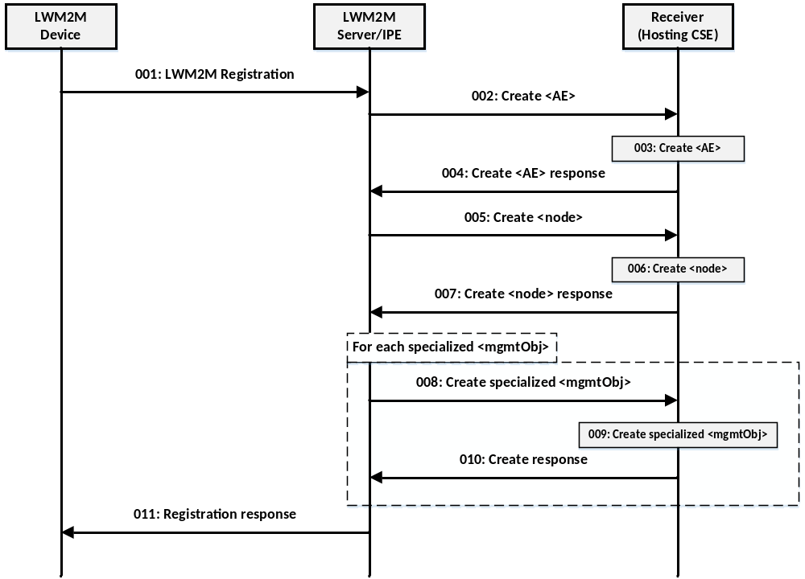
Figure 7-1 – End-to-end LWM2M Interworking Procedure

Step 001: A LWM2M device registers to the LWM2M Server and provides a list of supported LWM2M Objects. Co-located with the LWM2M Server is the IPE.
Step 002: In response to the LWM2M registration, the IPE requests to create an <AE> resource on the Hosting CSE on behalf of the LWM2M Device.
Step 003: The Hosting CSE evaluates the request, performs the appropriate checks, and creates the <AE> resource.
Step 004: A response is sent to the IPE indicating the <AE> resource was created.
Step 005: The IPE proceeds to create a <node> resource for the LWM2M Device so <mgmtObj> specialization resources can be created for AE’s to manage the device. As part of this multi-step procedure, the nodeLink attribute of the <AE> resource created in Step 003 is updated to point to the newly created <node> resource.
Step 006: The Hosting CSE creates the <node> resource and updates the <AE>’s nodeLink attribute as well.
Step 007: The Hosting CSE returns an appropriate response for creating the <node> resource.
Step 008: For each of the LWM2M Objects supported by the LWM2M Device, the IPE creates an appropriate specialized <mgmtObj> resource as a child of the <node> resource. This <mgmtObj> specialization maps one-for-one with the corresponding LWM2M Object.
Step 009: The Hosting CSE creates the <mgmtObj> specialization resource.
Step 010: An appropriate response is returned to the IPE for the creation of the <mgmtObj> specialization resource.
Step 011: The IPE/LWM2M Server completes the LWM2M registration procedure by sending the LWM2M Device an appropriate response.

Once the <mgmtObj> resources are created, attribute level subscriptions can be created to get notifications for certain desired operation such as a firmware update process. With the one-to-one mapping relationship between LWM2M resources and oneM2M [objectAttribute], attribute level subscriptions can be made. Table 7-1 shows a mapping of the LWM2M Firmware Update object to a new oneM2M Firmware <mgmtObj> with all the LWM2M resources mapped one for one to oneM2M attributes.
Table 7-1 – LWM2M Firmware Update Object Mapping to oneM2M <mgmtObj> Resource
LWM2M Resource Name | LWM2M Resource # | [objectAttribute]
Package | 0 | package
Package URI | 1 | pkgURI
Update | 2 | update
State | 3 | state
Update Result | 5 | updateResult
Pkg Name | 6 | pkgName
Pkg Version | 7 | pkgVersion
Firmware Update Protocol Support | 8 | firmwareUpdateProtocolSupport
Firmware Update Delivery Method | 9 | firmwareUpdateDeliveryMethod

The call flow below uses the updated Firmware Update object mapping in Table 7-1 to allow an AE to monitor the state of a firmware update on a LWM2M device. Prior to initiating a firmware update, the AE can subscribe to the state attribute of the 1:1 mapped firmware <mgmtObj> to get notifications of the firmware update process. Figure 7-2 shows the end-to-end use case of using oneM2M’s attribute level subscription to get notifications for the state of the firmware update.
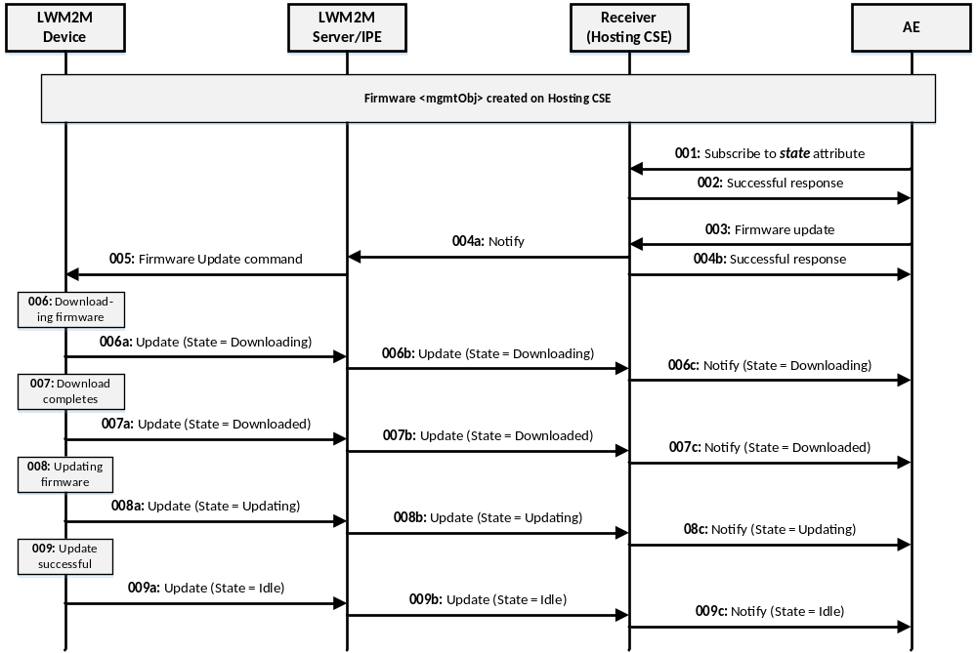
Figure 7-2 – oneM2M Attribute Level Subscription Use Case of LWM2M Firmware Update Process
Step 001: AE subscribes to the state attribute of the firmware <mgmtObj> associated with LWM2M Device.
Step 002: Hosting CSE grants the subscription and sends a successful response.
Step 003: AE sends a firmware update request to update the firmware on the LWM2M Device.
Step 004: Hosting CSE processes the request and performs the following:
a) Hosting CSE sends a Notify message to the IPE of the firmware update request.
b) Hosting CSE sends a successful response to the AE.
Step 005: The LWM2M Server/IPE sends a firmware update command to the LWM2M Device.
Step 006: The LWM2M Device receives the command and performs the download of the firmware image.
a) The LWM2M Device sends an update to the LWM2M Server with status that state = Downloading.
b) The LWM2M Server/IPE sends an update to the Hosting CSE with status that state = Downloading.
c) The Hosting CSE sends a notify to the AE with status that state = Downloading.
Step 007: The LWM2M Device completes the download and updates its state resource.
a) The LWM2M Device sends an update to the LWM2M Server with status that state = Downloaded.
b) The LWM2M Server/IPE sends an update to the Hosting CSE with status that state = Downloaded.
c) The Hosting CSE sends a notify to the AE with status that state = Downloaded.
Step 008: The LWM2M Device begins updating the firmware and updates its state resource.
a) The LWM2M Device sends an update to the LWM2M Server with status that state = Updating.
b) The LWM2M Server/IPE sends an update to the Hosting CSE with status that state = Updating.
c) The Hosting CSE sends a notify to the AE with status that state = Updating.
Step 009: The LWM2M Device completes updating the firmware successfully and updates its state resource.
a) The LWM2M Device sends an update to the LWM2M Server with status that state = Idle.
b) The LWM2M Server/IPE sends an update to the Hosting CSE with status that state = Idle.
c) The Hosting CSE sends a notify to the AE with status that state = Idle.

8 Conclusion
In oneM2M Release 3, the present document resulted in a set of normative updates to the oneM2M TS-0001, TS-0005 and TS-0014 specifications to add support for generically mapping LWM2M Objects to oneM2M <mgmtObj> resources. These normative updates were based on the methods described in clauses 6 and 7 of this document.
No further work is planned for this work item and it is recommended that this work item be closed.

Annex A:
The following text is duplicated from [i.11] for convenience to show the information an OMA LWM2M object definition file contains.

<?xml version="1.0" encoding="utf-8"?>

<!--
FILE INFORMATION

OMA Permanent Document
File: OMA-SUP-XML_LWM2M_Cellular_connectivity-V1_0-20170301-D
Type: xml

Public Reachable Information
Path: http://www.openmobilealliance.org/tech/profiles
Name: LWM2M_Cellular_connectivity-v1_0.xml

NORMATIVE INFORMATION

Information about this file can be found in the latest revision of

OMA-TS-LWM2M_ConnMgmt-V1_0

This is available at http://www.openmobilealliance.org/

Send comments to technical-comments@mail.openmobilealliance.org

CHANGE HISTORY

01032017 File created

LEGAL DISCLAIMER

Copyright 2017 Open Mobile Alliance All rights reserved.

Redistribution and use in source and binary forms, with or without
modification, are permitted provided that the following conditions
are met:

1. Redistributions of source code must retain the above copyright
notice, this list of conditions and the following disclaimer.
2. Redistributions in binary form must reproduce the above copyright
notice, this list of conditions and the following disclaimer in the
documentation and/or other materials provided with the distribution.
3. Neither the name of the copyright holder nor the names of its
contributors may be used to endorse or promote products derived
from this software without specific prior written permission.

THIS SOFTWARE IS PROVIDED BY THE COPYRIGHT HOLDERS AND CONTRIBUTORS
"AS IS" AND ANY EXPRESS OR IMPLIED WARRANTIES, INCLUDING, BUT NOT
LIMITED TO, THE IMPLIED WARRANTIES OF MERCHANTABILITY AND FITNESS
FOR A PARTICULAR PURPOSE ARE DISCLAIMED. IN NO EVENT SHALL THE
COPYRIGHT HOLDER OR CONTRIBUTORS BE LIABLE FOR ANY DIRECT, INDIRECT,
INCIDENTAL, SPECIAL, EXEMPLARY, OR CONSEQUENTIAL DAMAGES (INCLUDING,
BUT NOT LIMITED TO, PROCUREMENT OF SUBSTITUTE GOODS OR SERVICES;
LOSS OF USE, DATA, OR PROFITS; OR BUSINESS INTERRUPTION) HOWEVER
CAUSED AND ON ANY THEORY OF LIABILITY, WHETHER IN CONTRACT, STRICT
LIABILITY, OR TORT (INCLUDING NEGLIGENCE OR OTHERWISE) ARISING IN
ANY WAY OUT OF THE USE OF THIS SOFTWARE, EVEN IF ADVISED OF THE
POSSIBILITY OF SUCH DAMAGE.

The above license is used as a license under copyright only. Please
reference the OMA IPR Policy for patent licensing terms:
http://www.openmobilealliance.org/ipr.html
-->

<LWM2M xmlns:xsi="http://www.w3.org/2001/XMLSchema-instance" xsi:noNamespaceSchemaLocation="http://openmobilealliance.org/tech/profiles/LWM2M.xsd">
<Object ObjectType="MODefinition">
<Name>Cellular connectivity</Name>
<Description1><![CDATA[This object specifies resources to enable a device to connect to a 3GPP or 3GPP2 bearer, including GPRS/EDGE, UMTS, LTE, NB-IoT, SMS. For cellular connectivity, this object focuses on Packet Switched (PS) connectivity and doesn’t aim to provide comprehensive Circuit Switched (CS) connectivity management.
]]></Description1>
<ObjectID>10</ObjectID>
<ObjectURN>urn:oma:lwm2m:oma:10</ObjectURN>
<MultipleInstances>Single</MultipleInstances>
<Mandatory>Optional</Mandatory>
<Resources>
<Item ID="11"><Name>Activated Profile Names</Name>
<Operations>R</Operations>
<MultipleInstances>Multiple</MultipleInstances>
<Mandatory>Mandatory</Mandatory>
<Type>String</Type>
<RangeEnumeration></RangeEnumeration>
<Units></Units>
<Description><![CDATA[Links to instances of the “APN connection profile” object representing every APN connection profile that has an activated connection to a PDN.]]></Description>
</Item>
<Item ID="0"><Name>SMSC address</Name>
<Operations>RW</Operations>
<MultipleInstances>Single</MultipleInstances>
<Mandatory>Optional</Mandatory>
<Type>String</Type>
<RangeEnumeration></RangeEnumeration>
<Units></Units>
<Description><![CDATA[E.164 address of SMSC.
Applicable for 3GPP2 networks where SMSC is not available from a smart card, or for 3GPP/3GPP2 networks to provide the application with a customer specific SMSC. The application decides how to use this parameter, e.g. precedence over UICC based SMSC address.]]></Description>
</Item>
<Item ID="1"><Name>Disable radio period</Name>
<Operations>RW</Operations>
<MultipleInstances>Single</MultipleInstances>
<Mandatory>Optional</Mandatory>
<Type>Integer</Type>
<RangeEnumeration>0-65535</RangeEnumeration>
<Units>minutes</Units>
<Description><![CDATA[Time period for which the device shall disconnect from cellular radio (PS detach, CS detach if applicable).
Can be used to handle network overload situations.
The value is a positive integer (0 to 65535), duration can be from 1 minute to 65535 minutes (approximately 45 days).
As soon the server writes a value which is >0 the device SHALL disconnect. When the period has elapsed the device MAY reconnect.]]></Description>
</Item>
<Item ID="2"><Name>Module activation code</Name>
<Operations>RW</Operations>
<MultipleInstances>Single</MultipleInstances>
<Mandatory>Optional</Mandatory>
<Type>String</Type>
<RangeEnumeration></RangeEnumeration>
<Units></Units>
<Description><![CDATA[Configurable in case the application needs to issue a code (e.g. via AT command) to activate the module. e.g. “*98”.]]></Description>
</Item>
<Item ID="3"><Name>Vendor specific extensions</Name>
<Operations>R</Operations>
<MultipleInstances>Single</MultipleInstances>
<Mandatory>Optional</Mandatory>
<Type>Objlnk</Type>
<RangeEnumeration></RangeEnumeration>
<Units></Units>
<Description><![CDATA[Links to a vendor specific object.]]></Description>
</Item>
<Item ID="4"><Name>PSM Timer (1)</Name>
<Operations>RW</Operations>
<MultipleInstances>Single</MultipleInstances>
<Mandatory>Optional</Mandatory>
<Type>Integer</Type>
<RangeEnumeration>10min-992 days</RangeEnumeration>
<Units>s</Units>
<Description><![CDATA[Power saving mode (PSM) timer as defined in [3GPP-TS_23.682].
PSM Timer = Extended T3412.
Max interval between periodic TAU if there is no other transmission from the device. During most of this time the device is considered as unreachable and can therefore go into a deep sleep mode while keeping the PDN connection(s) active.]]></Description>
</Item>
<Item ID="5"><Name>Active Timer (1)</Name>
<Operations>RW</Operations>
<MultipleInstances>Single</MultipleInstances>
<Mandatory>Optional</Mandatory>
<Type>Integer</Type>
<RangeEnumeration>2sec-31 min</RangeEnumeration>
<Units>s</Units>
<Description><![CDATA[Active timer = T3324 as defined in [3GPP-TS_24.008].
The time the UE has to remain reachable after transitioning to idle state in case there is pending data from the NW to send out. At the end of T3324 UE can go into a deep sleep mode while keeping the PDN connection(s) active.]]></Description>
</Item>
<Item ID="6"><Name>Serving PLMN Rate control</Name>
<Operations>R</Operations>
<MultipleInstances>Single</MultipleInstances>
<Mandatory>Optional</Mandatory>
<Type>Integer</Type>
<RangeEnumeration></RangeEnumeration>
<Units></Units>
<Description><![CDATA[Only for when using Signalling Radio Bearers (c.f. Data over NAS), it indicates the maximum the number of allowed uplink PDU transmissions per 6 minute interval aggregated across all PDN connections. See [3GPP-TS_23.401], octet 3 to 4 of the Serving PLMN rate control IE.]]></Description>
</Item>
<Item ID="7"><Name>eDRX parameters for Iu mode (1)</Name>
<Operations>RW</Operations>
<MultipleInstances>Single</MultipleInstances>
<Mandatory>Optional</Mandatory>
<Type>Opaque</Type>
<RangeEnumeration>8 bits</RangeEnumeration>
<Units></Units>
<Description><![CDATA[Extended DRX parameters (Paging Time Window and eDRX value) for Iu mode which the UE can request from the network. This resource is encoded as octet 3 in [3GPP-TS_24.008, clause 10.5.5.32].]]></Description>
</Item>
<Item ID="8"><Name>eDRX parameters for WB-S1 mode (1)</Name>
<Operations>RW</Operations>
<MultipleInstances>Single</MultipleInstances>
<Mandatory>Optional</Mandatory>
<Type>Opaque</Type>
<RangeEnumeration>8 bits</RangeEnumeration>
<Units></Units>
<Description><![CDATA[Extended DRX parameters (Paging Time Window and eDRX value) for WB-S1 mode which the UE can request from the network. This resource is encoded as octet 3 in [3GPP-TS_24.008, clause 10.5.5.32].]]></Description>
</Item>
<Item ID="9"><Name>eDRX parameters for NB-S1 mode (1)</Name>
<Operations>RW</Operations>
<MultipleInstances>Single</MultipleInstances>
<Mandatory>Optional</Mandatory>
<Type>Opaque</Type>
<RangeEnumeration>8 bits</RangeEnumeration>
<Units></Units>
<Description><![CDATA[Extended DRX parameters (Paging Time Window and eDRX value) for NB-S1 mode which the UE can request from the network. This resource is encoded as octet 3 in [3GPP-TS_24.008, clause 10.5.5.32].]]></Description>
</Item>
<Item ID="10"><Name>eDRX parameters for A/Gb mode (1)</Name>
<Operations>RW</Operations>
<MultipleInstances>Single</MultipleInstances>
<Mandatory>Optional</Mandatory>
<Type>Opaque</Type>
<RangeEnumeration>8 bits</RangeEnumeration>
<Units></Units>
<Description><![CDATA[Extended DRX parameters (Paging Time Window and eDRX value) for A/Gb mode which the UE can request from the network. This resource is encoded as octet 3 in [3GPP-TS_24.008, clause 10.5.5.32].]]></Description>
</Item></Resources>
<Description2><![CDATA[Notes:
(1) This parameter is controlled by the 3GPP network. A LWM2M server may write a suggested value to this resource. As soon a LWM2M server changes the current value the device then suggests the new value to the network upon the next practical opportunity e.g. by inclusion of the requested value in an Attach or TAU request. In case the network confirms the suggested value then the device shall apply that value. In case the network provides a different value then the value provided by the network shall be applied by the device and the resource value shall be set to that value.
The LWM2M server may use the observe function to be notified upon any changes of PSM or Active timer. By using the observe function the LWM2M server will get notified in case the value suggested by the LWM2M server is not accepted by the network, or, if the value is changed by the network for any reason (e.g. if the device moves into new tracking areas there is no guarantee that the above values remain the same and are not altered by the network).
]]></Description2>
</Object>
</LWM2M>

Annex B:
The following text is a oneM2M template schema file used for mapping LWM2M object definition file to a oneM2M schema file. This template contains the oneM2M copyright notice, the schema namespace information, and the schema include sections that are common for all oneM2M resource schemas. Two XML element sections are reserved for resource specific mappings that are performed to interwork the LWM2M object definition file to oneM2M mgmtObj resource schema. The sections represent the oneM2M resource specific attributes and the corresponding announced resources, respectively. The “XXXXXX” shown in the template below should be replaced by the specific name of the corresponding oneM2M management object being defined.

<?xml version="1.0" encoding="UTF-8"?>
<!--
Copyright Notification

The oneM2M Partners authorize you to copy this document, provided that you retain all copyright and other proprietary notices
contained in the original materials on any copies of the materials and that you comply strictly with these terms.
This copyright permission does not constitute an endorsement of the products or services, nor does it encompass the granting of
any patent rights. The oneM2M Partners assume no responsibility for errors or omissions in this document.
© 2016, oneM2M Partners Type 1 (ARIB, ATIS, CCSA, ETSI, TIA, TSDSI, TTA, TTC). All rights reserved.

Notice of Disclaimer & Limitation of Liability

The information provided in this document is directed solely to professionals who have the appropriate degree of experience to understand
and interpret its contents in accordance with generally accepted engineering or other professional standards and applicable regulations.
No recommendation as to products or vendors is made or should be implied.

NO REPRESENTATION OR WARRANTY IS MADE THAT THE INFORMATION IS TECHNICALLY ACCURATE OR SUFFICIENT OR CONFORMS TO ANY STATUTE,
GOVERNMENTAL RULE OR REGULATION, AND FURTHER, NO REPRESENTATION OR WARRANTY IS MADE OF MERCHANTABILITY OR FITNESS FOR ANY
PARTICULAR PURPOSE OR AGAINST INFRINGEMENT OF INTELLECTUAL PROPERTY RIGHTS.
NO oneM2M PARTNER TYPE 1 SHALL BE LIABLE, BEYOND THE AMOUNT OF ANY SUM RECEIVED IN PAYMENT BY THAT PARTNER FOR THIS DOCUMENT, WITH RESPECT TO
ANY CLAIM, AND IN NO EVENT SHALL oneM2M BE LIABLE FOR LOST PROFITS OR OTHER INCIDENTAL OR CONSEQUENTIAL DAMAGES.
oneM2M EXPRESSLY ADVISES ANY AND ALL USE OF OR RELIANCE UPON THIS INFORMATION PROVIDED IN THIS DOCUMENT IS AT THE RISK OF THE USER.

-->

<xs:schema xmlns="http://www.w3.org/2001/XMLSchema-instance" targetNamespace="http://www.onem2m.org/xml/protocols"
xmlns:m2m="http://www.onem2m.org/xml/protocols" elementFormDefault="unqualified"
attributeFormDefault="unqualified" xmlns:xs="http://www.w3.org/2001/XMLSchema">
<xs:include schemaLocation="CDT-commonTypes-v2_8_0.xsd" />
<xs:include schemaLocation="CDT-subscription-v2_8_0.xsd" />
<xs:element name="XXXXXX" substitutionGroup="m2m:sg_mgmtResource">
<xs:complexType>
<xs:complexContent>
<!-- Inherit common attributes from mgmtResource -->
<xs:extension base="m2m:mgmtResource">
<xs:sequence>
<!-- Resource Specific Attributes -->

<!-- Child Resources -->
<xs:choice minOccurs="0" maxOccurs="1">
<xs:element name="childResource" type="m2m:childResourceRef" maxOccurs="unbounded" />
<xs:element ref="m2m:subscription" maxOccurs="unbounded" />
</xs:choice>
</xs:sequence>
</xs:extension>
</xs:complexContent>
</xs:complexType>
</xs:element>
<xs:element name="XXXXXXAnnc" substitutionGroup="m2m:sg_announcedMgmtResource">
<xs:complexType>
<xs:complexContent>
<!-- Inherit common attributes from announcedMgmtResource -->
<xs:extension base="m2m:announcedMgmtResource">
<xs:sequence>
<!-- Resource Specific Attributes -->
<!-- Child Resources -->
<xs:choice minOccurs="0" maxOccurs="1">
<xs:element name="childResource" type="m2m:childResourceRef" maxOccurs="unbounded" />
<xs:element ref="m2m:subscription" maxOccurs="unbounded" />
</xs:choice>
</xs:sequence>
</xs:extension>
</xs:complexContent>
</xs:complexType>
</xs:element>
</xs:schema>

Annex C:
The following text shows an example schema file for the LWM2M Cellular connectivity object.

<?xml version="1.0" encoding="UTF-8"?>
<!--
Copyright Notification

The oneM2M Partners authorize you to copy this document, provided that you retain all copyright and other proprietary notices
contained in the original materials on any copies of the materials and that you comply strictly with these terms.
This copyright permission does not constitute an endorsement of the products or services, nor does it encompass the granting of
any patent rights. The oneM2M Partners assume no responsibility for errors or omissions in this document.
© 2016, oneM2M Partners Type 1 (ARIB, ATIS, CCSA, ETSI, TIA, TSDSI, TTA, TTC). All rights reserved.

Notice of Disclaimer & Limitation of Liability

The information provided in this document is directed solely to professionals who have the appropriate degree of experience to understand
and interpret its contents in accordance with generally accepted engineering or other professional standards and applicable regulations.
No recommendation as to products or vendors is made or should be implied.

NO REPRESENTATION OR WARRANTY IS MADE THAT THE INFORMATION IS TECHNICALLY ACCURATE OR SUFFICIENT OR CONFORMS TO ANY STATUTE,
GOVERNMENTAL RULE OR REGULATION, AND FURTHER, NO REPRESENTATION OR WARRANTY IS MADE OF MERCHANTABILITY OR FITNESS FOR ANY
PARTICULAR PURPOSE OR AGAINST INFRINGEMENT OF INTELLECTUAL PROPERTY RIGHTS.
NO oneM2M PARTNER TYPE 1 SHALL BE LIABLE, BEYOND THE AMOUNT OF ANY SUM RECEIVED IN PAYMENT BY THAT PARTNER FOR THIS DOCUMENT, WITH RESPECT TO
ANY CLAIM, AND IN NO EVENT SHALL oneM2M BE LIABLE FOR LOST PROFITS OR OTHER INCIDENTAL OR CONSEQUENTIAL DAMAGES.
oneM2M EXPRESSLY ADVISES ANY AND ALL USE OF OR RELIANCE UPON THIS INFORMATION PROVIDED IN THIS DOCUMENT IS AT THE RISK OF THE USER.
-->

<xs:schema xmlns="http://www.w3.org/2001/XMLSchema-instance" targetNamespace="http://www.onem2m.org/xml/protocols"
xmlns:m2m="http://www.onem2m.org/xml/protocols" elementFormDefault="unqualified"
attributeFormDefault="unqualified" xmlns:xs="http://www.w3.org/2001/XMLSchema">

<xs:include schemaLocation="CDT-commonTypes-v2_8_0.xsd" />
<xs:include schemaLocation="CDT-subscription-v2_8_0.xsd" />

<xs:element name="cellularConnectivity" substitutionGroup="m2m:sg_mgmtResource">
<xs:complexType>
<xs:complexContent>
<!-- Inherit common attributes from mgmtResource -->
<xs:extension base="m2m:mgmtResource">
<xs:sequence>
<!-- Resource Specific Attributes -->
<xs:element name="activatedProfileNames" type="xs:string" minOccurs="1" maxOccurs="unbounded" />
<xs:element name="smscAddress" type="xs:string" minOccurs="0" maxOccurs="1" />
<xs:element name="disableRadioPeriod" type="xs:integer" minOccurs="0" maxOccurs="1" />
<xs:element name="moduleActivationCode" type="xs:string" minOccurs="0" maxOccurs="1" />
<xs:element name="vendorSpecificExtensions" type="xs:string" minOccurs="0" maxOccurs="1" />
<xs:element name="psmTimer" type="xs:integer" minOccurs="0" maxOccurs="1" />
<xs:element name="activeTimer" type="xs:integer" minOccurs="0" maxOccurs="1" />
<xs:element name="servingPLMNRateControl" type="xs:integer" minOccurs="0" maxOccurs="1" />
<xs:element name="eDRXParametersForIuMode" type="xs:base64Binary" minOccurs="0" maxOccurs="1" />
<xs:element name="eDRXParametersForWB-S1Mode" type="xs:base64Binary" minOccurs="0" maxOccurs="1" />
<xs:element name="eDRXParametersForNB-S1Mode" type="xs:base64Binary" minOccurs="0" maxOccurs="1" />
<xs:element name="eDRXParametersForAGbMode" type="xs:base64Binary" minOccurs="0" maxOccurs="1" />

<!-- Child Resources -->
<xs:choice minOccurs="0" maxOccurs="1">
<xs:element name="childResource" type="m2m:childResourceRef" maxOccurs="unbounded" />
<xs:element ref="m2m:subscription" maxOccurs="unbounded" />
</xs:choice>
</xs:sequence>
</xs:extension>
</xs:complexContent>
</xs:complexType>
</xs:element>

<xs:element name="cellularConnectivityAnnc" substitutionGroup="m2m:sg_announcedMgmtResource">
<xs:complexType>
<xs:complexContent>
<!-- Inherit common attributes from announcedMgmtResource -->
<xs:extension base="m2m:announcedMgmtResource">
<xs:sequence>
<!-- Resource Specific Attributes -->
<xs:element name="activatedProfileNames" type="xs:string" minOccurs="1" maxOccurs="unbounded" />
<xs:element name="smscAddress" type="xs:string" minOccurs="0" maxOccurs="1" />
<xs:element name="disableRadioPeriod" type="xs:integer" minOccurs="0" maxOccurs="1" />
<xs:element name="moduleActivationCode" type="xs:string" minOccurs="0" maxOccurs="1" />
<xs:element name="vendorSpecificExtensions" type="xs:string" minOccurs="0" maxOccurs="1" />
<xs:element name="psmTimer" type="xs:integer" minOccurs="0" maxOccurs="1" />
<xs:element name="activeTimer" type="xs:integer" minOccurs="0" maxOccurs="1" />
<xs:element name="servingPLMNRateControl" type="xs:integer" minOccurs="0" maxOccurs="1" />
<xs:element name="eDRXParametersForIuMode" type="xs:base64Binary" minOccurs="0" maxOccurs="1" />
<xs:element name="eDRXParametersForWB-S1Mode" type="xs:base64Binary" minOccurs="0" maxOccurs="1" />
<xs:element name="eDRXParametersForNB-S1Mode" type="xs:base64Binary" minOccurs="0" maxOccurs="1" />
<xs:element name="eDRXParametersForAGbMode" type="xs:base64Binary" minOccurs="0" maxOccurs="1" />

<!-- Child Resources -->
<xs:choice minOccurs="0" maxOccurs="1">
<xs:element name="childResource" type="m2m:childResourceRef" maxOccurs="unbounded" />
<xs:element ref="m2m:subscription" maxOccurs="unbounded" />
</xs:choice>
</xs:sequence>
</xs:extension>
</xs:complexContent>
</xs:complexType>
</xs:element>
</xs:schema>

History

Publication history
V.1.1.1 | <yyyy-mm-dd> | <Milestone>

Draft history (to be removed on publication)
V.0.0.1 | 10 Oct 2016 | Initial skeleton
V.0.2.0 | 20 Nov 2016 | New baseline  Incorporated Contributions:  MAS-2016-0221-CR-LWM2M_DM_Interworking_Analysis  MAS-2016-0426-CR-LWM2M_DM_Interworking_Solution
V.0.3.0 | 27 Feb 2017 | Updated to 2017 TR template  Incorporated Contribution:  MAS-2017-0014R01-Generic_Procedure_for_Mapping_of_LWM2M_Objects.doc
V.0.4.0 | 10 Apr 2017 | Incorporated Contribution:  MAS-2017-0045R02-TR-0031_Updates_to_LWM2M_DM_Interworking.doc

